Oklahoma World Organization of China Painters, Inc.

QUARTERLY BOARD MEETING
January 14, 2023

I. WELCOME/PRAYER

The January Quarterly Meeting of the OK WOCP INC. was held at the WOCP World Museum and via ZOOM for members unable to attend.

President Ann Truscott welcomed members in attendance and introduced Shirley Weston, who lead the members in prayer.

II. ROLL CALL / MINUTES

The Roll Call was conducted by Corporate Secretary Ruthanne Reitz. State Officers, Past State Presidents, and Club Delegates were counted, and a quorum was reached for the meeting.

The Minutes from the Quarterly Meeting held on September24, 2022 had been sent to all state club members via Email by Ruthanne Reitz. The minutes were accepted as presented.

III. TREASURER’S REPORT

Treasurer Sharan Amend’s report was shared in printed handouts and approved as presented. The reported balance was $3,373.06. See Attachment A.

IV. COMMITTEE REPORTS

A. STANDING COMMITTEES

1. BY–LAWS: Shirley Weston, Chairperson, commented that the Standing Rule Proposal made at the September meeting concerning the payment of a fee equivalent to the WOCP Art Institute fee for attendance by the Oklahoma State President or that amount instead to pay for the WOCP World Show or the Art Institute. No travel or lodging expenses were to be included. She suggested that the fee be limited to $400 based on the latest Art Institute fee. A motion was made by Sharon Amend to discuss the Standing Rule and seconded by Fern Lynch. After a brief discussion, this motion was approved.

P. 1 of 5
Shirley also reported the current problem of meeting a quorum. Many organizations are having this problem, and she reported a possible solution of a new Standing Rule that only a simple majority be required. An average of attendees may be used. This can be achieved with a Standing Rule. Our By-Laws require that names of authorized representatives for each club and officer must be submitted some time before the meeting. This is not always possible, and this rule needs elimination.

Sharan Amend made a motion to delete Article C in the Standing Rules because of the problem of attendance. Fillis Jackson seconded the motion. The motion passed. Shirley submitted a new Standing Rule to clearly define what the simple majority constitutes. After some discussion, a vote was taken and the motion passed. See Attachment B.

2. BUDGET AND FINANCE: Sharan Amend discussed the Treasurer’s Report briefly and said that we have two CDs renewing, one in February 2023, and one in April 2023.

Lois Higgins, Chairperson of the Educational Funds Committee, reported that the February CD will renew at .40% and the April CD will renew at .50%. Thelma Ingram stated that there are better rates now and Ann Truscott said that they probably need to be investigated. Shirley suggested finding a two-year rate and putting them both in a better rate when the renewal date arrives. Lois agreed that it was a good plan. It was left open for Lois to decide on acceptable rates. See Attachment C.

3. YEARBOOK: Ann Truscott thanked Lois Higgins for her years of work updating and printing the yearbook. She is leaving this position and will be replaced. Ann commented that Lois will be difficult to replace.

4. PUBLICITY: Susan Schmidt reported that the Oklahoma State Capitol has been renovating and the exhibition of art has been resumed. The Oklahoma Arts Council is promoting many exhibitions, with the public invited to participate. Susan distributed handouts with further information for those interested in this.

5. MEMBERSHIP: No Report.

6. FINE ARTS: Fillis Jackson reported that the Live Judging Competition for China Painting at the Oklahoma State Fair in the Fall will possibly have the theme of “Fanciful Shoes.” There will be a size requirement of an 8 to 9 inch plate, square or round. No other details are

P. 2 of 5
known at this time.

7. NOMINATING COMMITTEE: Susan Gee, Chairperson, stated that the committee is working on a slate of officers to be presented at the April Annual Meeting. Susan Whitley has agreed to assume the duties as the new OK WOCP, INC. President at that time. The slate of officers will be presented to the membership for approval at the April Meeting.

8. EVENTS COMMITTEE: Fillis Jackson reported that the statewide meeting, “A Gathering of Friends,” will be held on April 21, 2023 at the WOCP World Museum in Oklahoma City. A guest demonstrator, Sharon Scholz from Colorado, will bring a presentation for all attending, There will also be two Board Meetings, the Annual Meeting at 9:00 a.m., and the Quarterly Meeting at 1:00 p.m. A Formal Tea will be enjoyed, and attendees are invited to wear their finest tea party hats (or fascinators) for the event. Beautiful china painted tea pots will serve the tea. An auction for the tea pots hand painted by Oklahoma members will also occur after the tea party. Artists include Shirley Weston, Bernetta Stewart, Adrienne Mauch, Le Yeatts, Peggy Dennis and Fillis Jackson. Lunch will be served. There will also be a china sale. The Pauline A. Salyer Award for an outstanding member will be announced. Nomination rules have been sent to members by Sharan Amend, and are due back to her by March 24, 2023. The Museum balloting will also occur that day, and all will have an opportunity to view the entries from each club. Bring your painted pieces to show that day for the voting, or they may be dropped off at the museum. Door prizes will be given, along with other surprises. A very enjoyable “Gathering of Friends” is expected.

9. GRANTS AND SCHOLARSHIPS COMMITTEE: No report.

10. PAULINE A. SALYER AWARD: Sharan Amend sent out Emails to club presidents in December with the application and rules for the Pauline A. Salyer Award. The due date for all applications to be received by her is March 24, 2023.

11. OK WOCP INC EDUCATION FUNDS: A contract with Sharon Scholz was presented by Sooner Leisure Porcelain Art Club for a seminar to be held at the Museum for four days, April 24 – 27, 2023, for the club. This will include 10 members. The cost is $250 per day, with a total of $1000.
Fillis Jackson presented a motion from the Sooner Leisure Porcelain Art Club to request a payment of ½ of the Teacher’s Fee, which would equal $500, to be awarded from the OK WOCP INC Education Funds. Shirley Weston seconded the motion. The motion passed.

A contract with Sharon Scholz was presented by Lois Higgins for a three-day seminar in Bixby, Oklahoma with the Oil Capital China Painters Club. The dates are April 17, 18, and 19, 2023 for the club at a rate of $250 per day. The total fee will be $750.
Lois Higgins made a motion from Oil Capital China Painters Club requesting an amount of $325
from the OK WOCP INC Education Funds., equaling ½ of the Teacher’s Fee. This is to be awarded

P. 3 of 5
awarded from the OK WOCP INC Education Funds. Sarah Gomez seconded the motion. The motion passed.

Fillis Jackson made a motion for OK WOCP INC to pay $150 to Sharon Scholz for the two-hour demonstration she has agreed to present at the April 21, 2023 meeting. Sharan Amend seconded the motion. The motion carried with two members dissenting.

12. MUSEUM BALLOT COMMITTEE: Ann announced that a replacement needs to be made for Dorothy Anderson, Museum Ballot Chairperson, due to her recent death. Ann appointed Susan Owen, and Lois Higgins is a committee member. Sharan Amend noted that all entries must be entered at the Museum this year.

V. OLD BUSINESS

A. Asa Baldwin will be in Oklahoma this summer for the seminar that was scheduled with her. Two of the people whose names were drawn have dropped out, and there are still five alternate members from which to draw.

B. A memory page has been established on the Web from Dorothy Anderson’s Club.

Sarah stated that a section for 2022-23 photos was set up. Photos are needed and you may Email them to Sarah Gomez, Webmaster. Sarah also suggested subscribing to the Zoom meeting yearly fee.

VI. NEW BUSINESS

A. Susan Schmidt discussed the free Docent training at the Oklahoma Capitol Building. The phone number is 405-521-6213. She also mentioned that Zoom meetings can be used through the OK WOCP for online lessons from Paula White. The cost for each person is $10.

B. Nancy Lepak stated that the World Show has been scheduled for August 1 – 5, 2023 at the Campus of the University of Northwestern in St. Paul, Minnesota.

C. The meeting was adjourned.

P. 4 of 5

By unanimous action the Board confirmed, approved, and ratified all actions taken by the officers of the OK WOCP INC., and resolved that all such acts and actions were duly authorized and were therefore ratified and confirmed as acts and actions on behalf of the OK WOCP INC.

Respectfully submitted,

Ruthanne Reitz, Corporate Secretary
Oklahoma World Organization of China Painters, Inc.

The undersigned, being an officer of OK WOCP INC., does hereby consent to all action taken at said meeting as reflected in the foregoing minutes, dated January 21, 2023.

Ann Truscott, President
Oklahoma World Organization of China Painters, Inc.
(OK WOCP INC.)

P. 5 of 5

Attachment A.
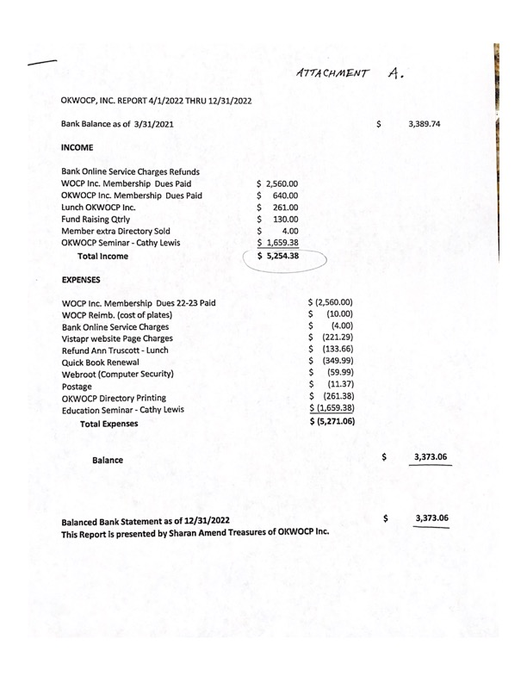

Attachment B.

A majority of the eligible voting membership shall compose a quorum at any Board Meeting. A simple majority of the quorum shall constitute the outcome of the vote. A quorum of all voting members may not always be achievable; therefore, the quorum will be the average of the attendance at meetings which must include at least three Executive Board Members and three Past Presidents with each voting member having only one vote.

Submitted by Shirley Weston

January 14, 2023

